Java Script Basics:

1. Different ways to print in different ways :

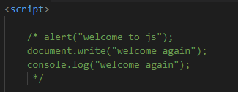

Function:

1. Write No argument function:

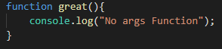

To call the function:



Output:

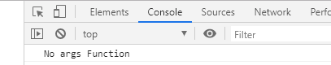

1. Write argument functions:

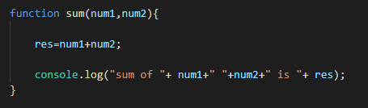

To call the function:



Output:

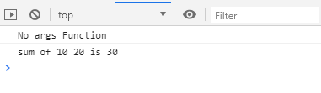

1. Another Example in functions:

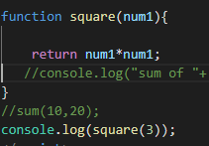

Output:

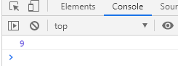

Note:

Java script does not contain any return type. If its integer return int, if its string return string value. Please observe in above example.

1. Write a code in JS file and run in node server.

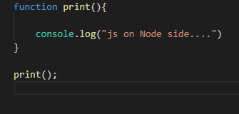

Output:



Another Example:

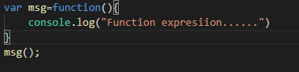

Output:

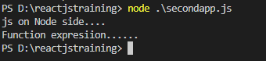

If you calling a function before declaration two different ways:

1. Below example is not a functional expression so it’s execute successful.

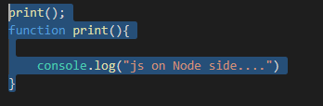

Output:



1. Below mentioned function is the functional expression so in this case it does not execute.

Function expression:

The function name. Can be omitted, in which case the function is anonymous. The name is only local to the function body.

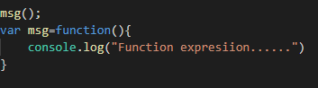

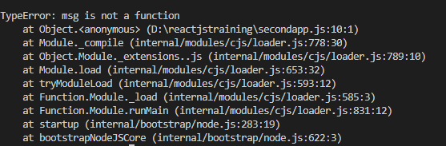

3rd way to declare function:



